Section 1: General IT Knowledge

1. Multiple-choice questions on fundamental IT concepts:
   * What does "IT" stand for?
     + a) Information Technology
     + b) International Technology
     + c) Integrated Telecommunications
     + d) Internet Training
   * What is the purpose of a firewall in network security?

Section 2: Programming and Development

1. Questions related to programming languages and development:
   * Which programming language is known for its use in web development?
   * What does HTML stand for?
   * What is the purpose of a version control system like Git?

Section 3: Networking

1. Questions on networking:
   * Define what an IP address is.
   * What is the OSI model, and how many layers does it have?
   * How does DNS work, and what is its purpose?

Section 4: IT Security

1. Basic IT security questions:
   * What is phishing, and how can it be prevented?
   * Define malware and provide an example.
   * What are some best practices for securing a computer or network?

Section 5: Problem Solving and Troubleshooting

1. **Scenario-based questions:**
   * A user reports that their computer is running very slowly. Describe the steps you would take to troubleshoot and resolve the issue.

AAn application is crashing with an error message. What steps would you take to diagnose and fix the problem?

**Section 6: Practical Skills (Optional)**

If relevant to the role, you can include a practical task, such as writing a short code snippet, configuring a network setting, or solving a simple IT problem.

**Section 7: Open-Ended Questions (Optional)**

Allow candidates to provide detailed answers to open-ended questions, demonstrating their problem-solving and communication skills.

Remember to adapt the questions to the specific job requirements and level of expertise you are looking for in candidates. Additionally, you may want to time-limit the test and provide candidates with clear instructions on how to submit their answers online.

What will be the output of the program?

1 point

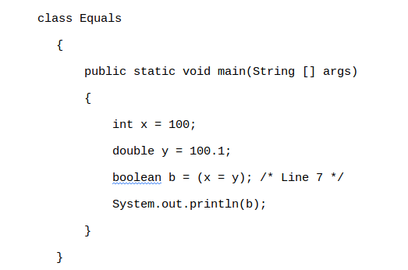

Class equal {

Public static void main(string[] args)

{int x= 100;

Double y=100.1;

Boolean b= (x=y);

System.out.println(b)

}

}

Main()

{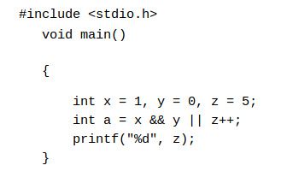

Main(){

Int x=1,y=0,z=5;

Int a=x && y||z++;

Printf(“%d”,z);

}

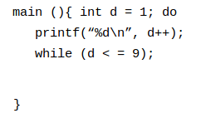

Main(){

Int d=;do

Printf(“%d\n”,d++)

While (d<=9)

}

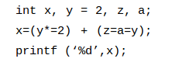

Int x,y=2,z,a;

X=(y*=3) +(z=a=y);

Printf(‘%d’x);

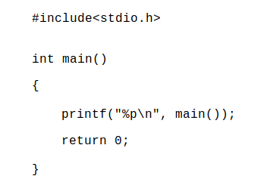

Main(){

Printf(“%p\n”,main());

Return 0;

}